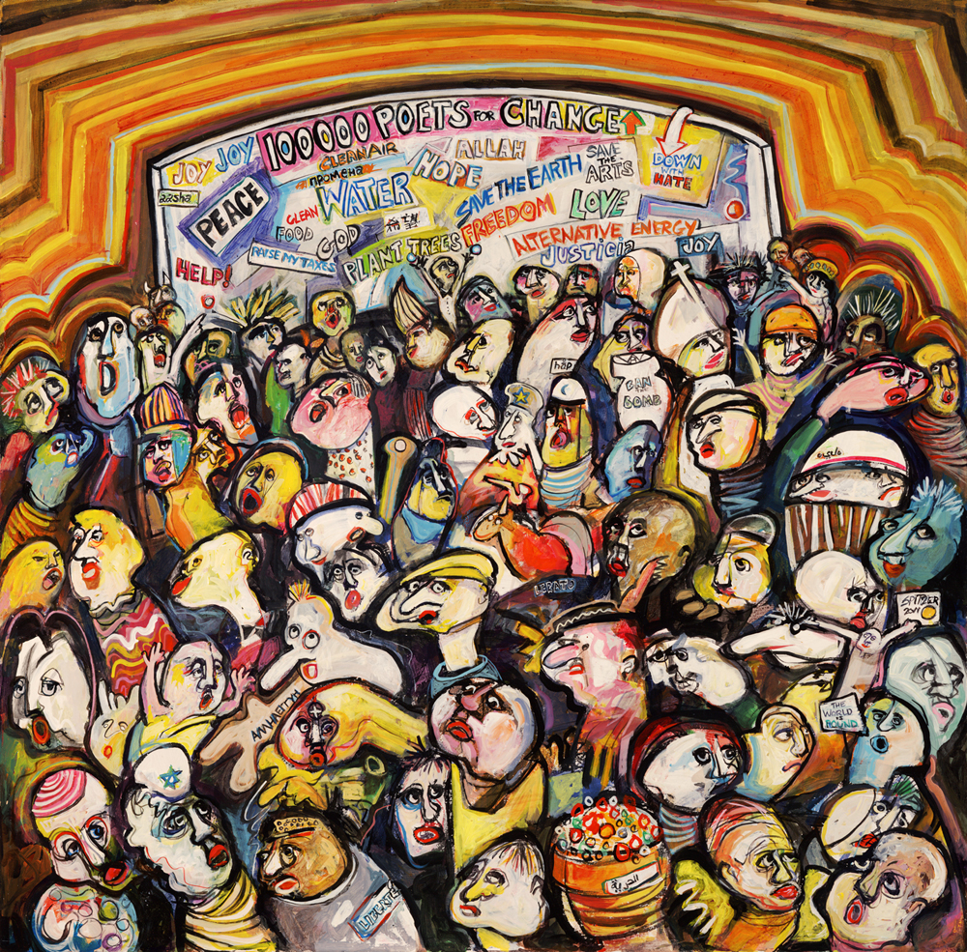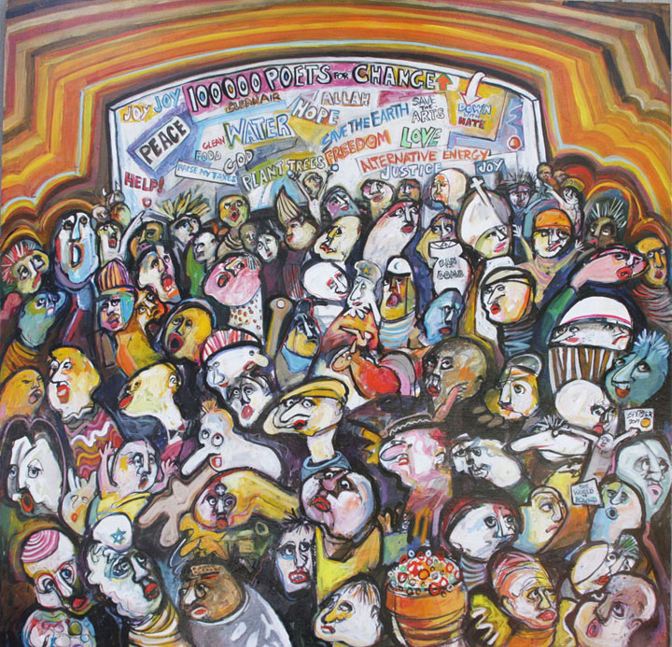 

100 Thousand Poets for Change began in Sonoma County, CA in 2011.

The 100 Thousand Poets for Change Headquarters Event in Santa Rosa, CA is sponsored by the Peace & Justice Center and Sonoma County Arts Council.

Immediately following September 29th, all documentation on the 100TPC.org website will be preserved by Stanford University in California, which recognized 100 Thousand Poets for Change in 2011 as an historical event, the largest poetry reading in history. They will continue to archive the complete contents of the website, 100TPC.org, as part of their digital archiving program LOCKSS.

Visit www.100TPC.org

### What else?

If you would like to organize an event in your community for

September 29, 2012 sign up online at 100TPC.org or

write to us with any questions you may have at

walterblue@bigbridge.org

September 29, 2012

Poets, musicians and artists around the world are planning individual events to take place simultaneously on Sept.29th 2012 in a demonstration/celebration of poetry, art and music to promote social, environmental, and political change…

**A three-day event in Santa Rosa, CA**! Sept. 28, 29, & 30, at the Arlene Francis Center that will **live-stream events from around the world** and feature live poetry readings, workshops and various musicians and dancers including hip hop, flamenco, African drums, reggae and more

2 days of poetry and art in **San Francisco, CA** at the **Beat Museum** in North Beach.

A concert of **Tibetan music and poetry** hosted by 100 TPC Free Tibet in Los Angeles

An **all day festival** with multiple stages and over **50 poetry readings** hosted by **Beyond Baroque Cultural Center in Los Angeles**

A blues festival in **New Orleans** to help raise funds for medical care for aging musicians

An Occupy Wall Street poetry group will kickoff a weekend of events in **New York City**

A concert in **Nashville’s Centennial Park**

There are Poetry and peace gatherings planned in strife-torn countries like **Syria and Afghanistan** as well. In **Cairo and Alexandria, Egypt**, poets, musicians and mimes will perform in public spaces and theaters. In **Kingston, Jamaica** an entire week of concerts, spoken word performances, lectures and workshops will address literacy issues in the country.

This is just a small sampling of the over 580 events planned around the world for 100TPC 2012!

“the beauty of the concept of 100 Thousand Poets for Change is

that it is completely decentralized and completely inclusive.”

- Bob Holman & Margery Snyder, About.com.

# What is 100 Thousand Poets for Change?

100 Thousand Poets for Change is an annual event in which poets, musicians and artists around the world come together to call for environmental, social and political change. On September 29, 2012, concerts, readings, workshops, flash mobs parades and demonstrations will take place in more than 109 countries around the world.

100 Thousand Poets for Change’s Founders Michael Rothenberg and Terri Carrion stated that peace and sustainability, “…is a major concern worldwide and the guiding principle for this global event.” All participants are hoping, through their actions and events, to seize and redirect the political and social dialogue of the day and turn the narrative of civilization towards peace and sustainability.

## 650 Events in 115 Countries and Counting!

What kind of CHANGE are we talking about?

*The first order of change is for poets, writers, musicians, artists, anybody, to actually get together to create and perform, educate and demonstrate, simultaneously, with other communities around the world. This will change how we see our local community and the global community. We have all become incredibly alienated in recent years. We hardly know our neighbors down the street let alone our creative allies who live and share our concerns in other countries. We need to feel this kind of global solidarity.*

*- Co-founder Michael* Rothenberg

**Each event organizer has their own Blog page on the 100TPC site to document their event with photos, audio, video and more, and share with the rest of the world! The entire online archive of all 100TPC events will be preserved by Stanford University.**